Computer Networking

Assignment 4

**Name: 陈应权**

**Student number: 2022280297**

Problem 1: CRC Error Detection (10 points)

**R=0100,when D is 1010101010.**

**R=1000,when D is 1000100101.** **The specific calculation process is as follows:**

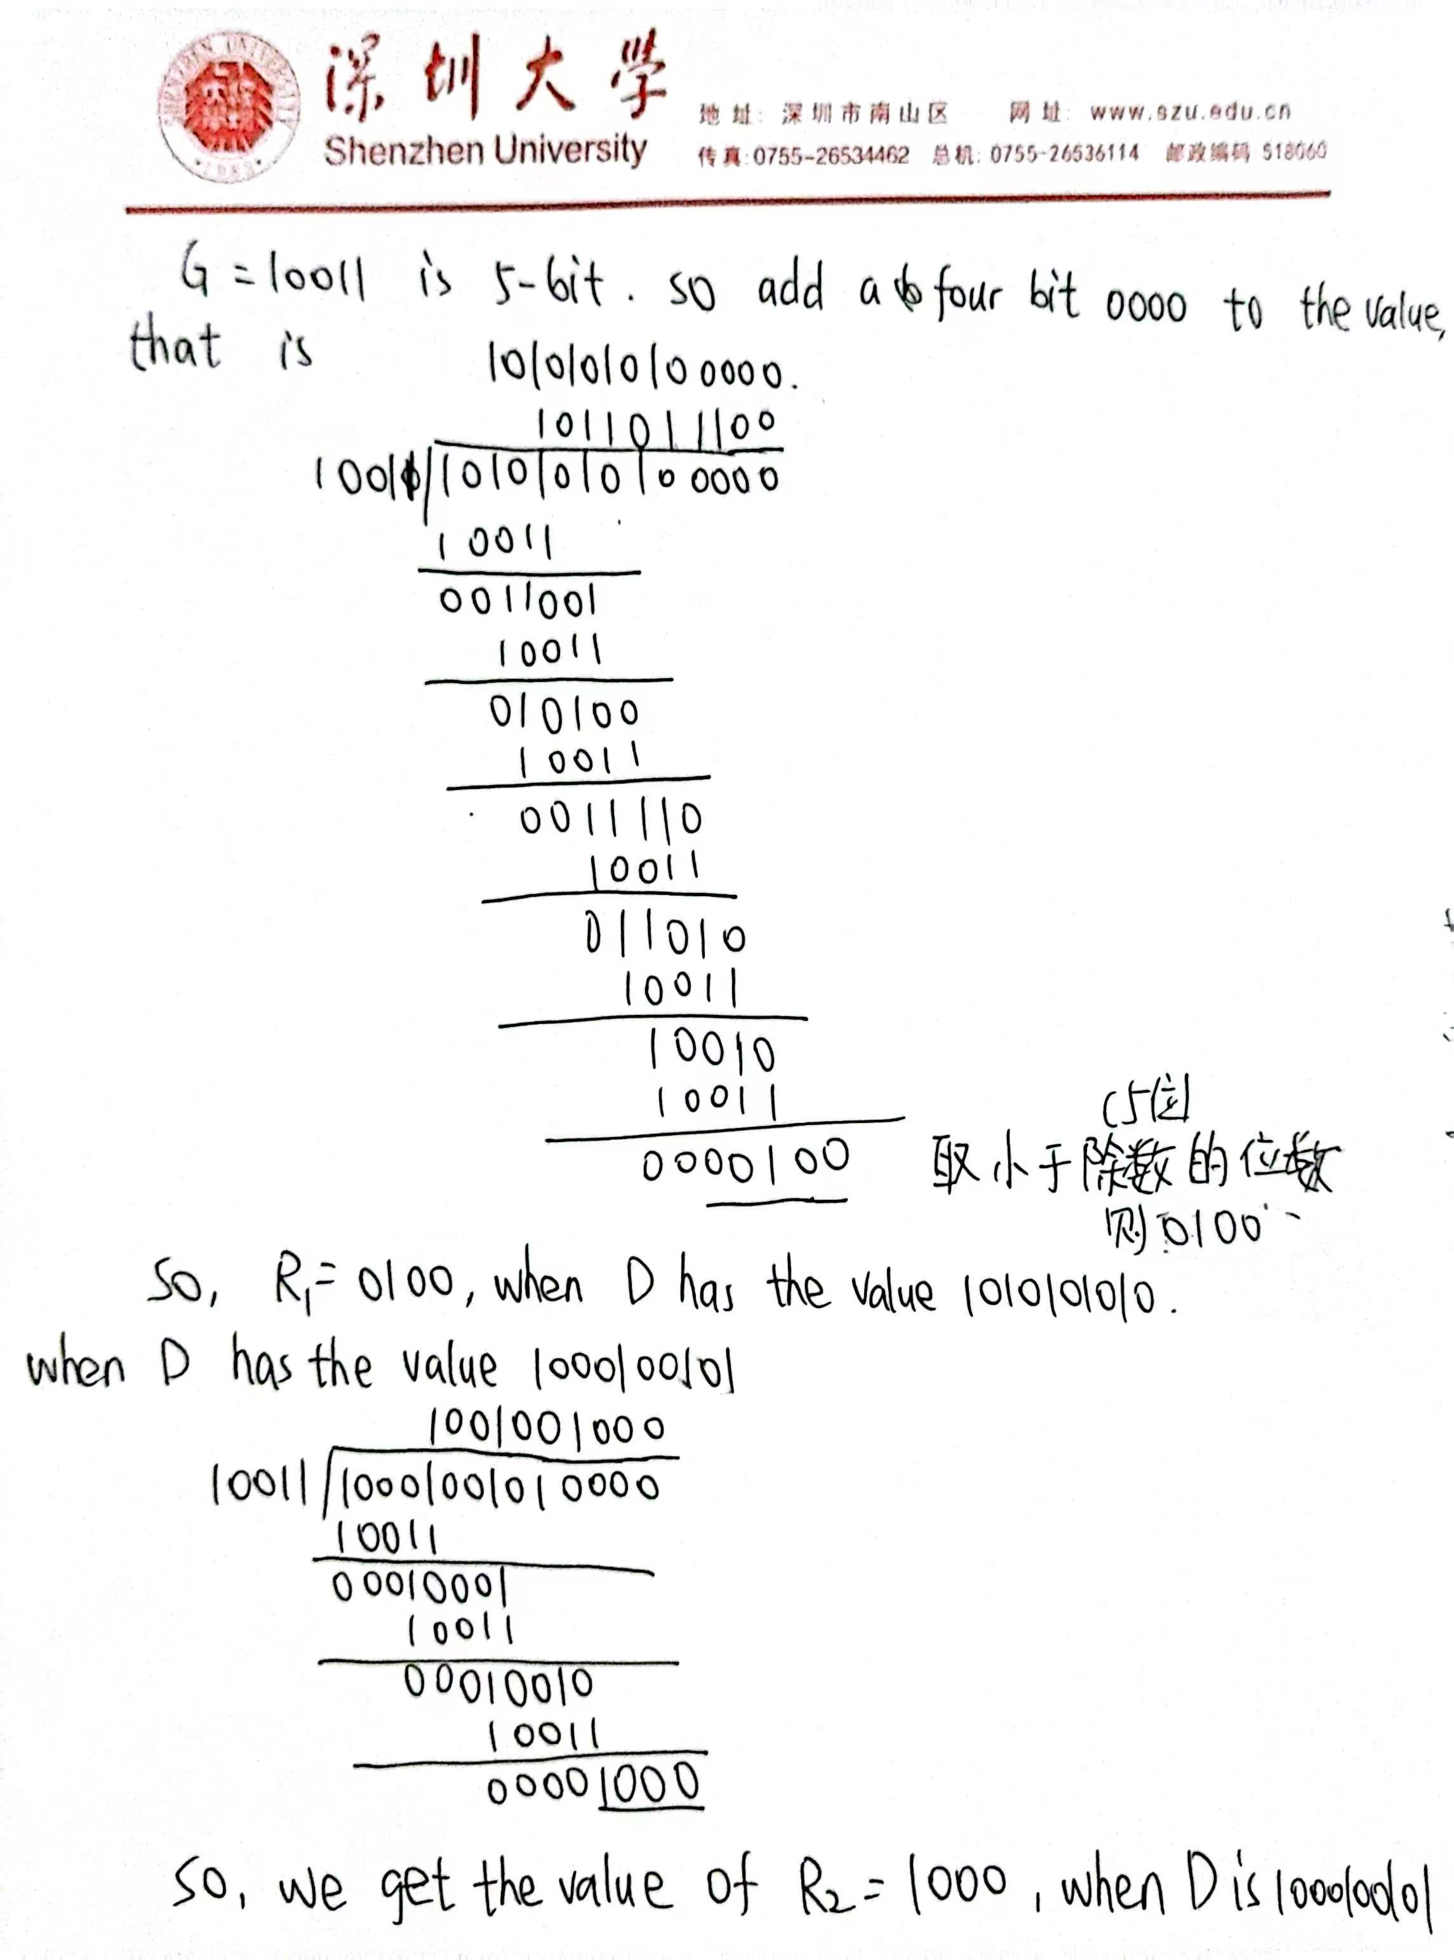

Problem 2: Slotted Aloha (10 points)

**(1) Without loss of generality, suppose ith bit is flipped, where 0<= i <= d+r-1 and**

**assume that the least significant bit is 0th bit.**

**A single bit error means that the received data is K=D*2r XOR R + 2i. It is clear that if we divide K by G, then the reminder is not zero. In general, if G contains at least two 1’s, then a single bit error can always be detected.**

**(2) NO. The key insight here is that G can be divided by 11 (binary number), but any number of odd-number of 1’s cannot be divided by 11. Thus, a sequence (not necessarily**

**contiguous) of odd-number bit errors cannot be divided by 11, thus it cannot be**

**divided by G.**

Problem 3: ARP protocol (15 points)

**(1) No. E can check the subnet prefix of Host F’s IP address, and then learn that F is on**

**the same LAN. Thus, E will not send the packet to the default router R1.**

**Ethernet frame from E to F:**

**Source IP = E’s IP address**

**Destination IP = F’s IP address**

**Source MAC = E’s MAC address**

**Destination MAC = F’s MAC address**

**(2)**

**No, E will not perform an ARP query to find B’s MAC address ,because they are not on the same LAN. E can find this out by checking B’s IP address.**

**Ethernet frame from E to R1:**

**Source IP = E’s IP address**

**Destination IP = B’s IP address**

**Source MAC = E’s MAC address**

**Destination MAC = The MAC address of R1’s interface connecting to Subnet 3**

**(3)** ①What actions will switch S1 perform once it receives the ARP request message?

**Switch S1 will broadcast the Ethernet frame via both its interfaces as the received**

**ARP frame’s destination address is a broadcast address. And it learns that A resides**

**on Subnet 1 which is connected to S1 at the interface connecting to Subnet 1. And, S1**

**will update its forwarding table to include an entry for Host A.**

②Will router R1 also receive this ARP request message? If so, will R1 forward the message to Subnet 3?

**Yes, router R1 also receives this ARP request message, but R1 won’t forward the message to Subnet 3.**

**③**Once Host B receives this ARP request message, it will send back to Host A an ARP response message. But will it send an ARP query message to ask for A’s MAC address?

**B won’t send ARP query message asking for A’s MAC address, as this address can be obtained from A’s query message.**

④What will switch S1 do once it receives an ARP response message from Host B?

**Once switch S1 receives B’s response message, it will add an entry for host B in its forwarding table, and then drop the received frame as destination host A is on the same interface as host B (i.e., A and B are on the same LAN segment).**

Problem 4: Switch self-learning (15 points)

|  |  |  |  |
| --- | --- | --- | --- |
| Action | Switch Table State | Link(s) packet is forwarded to | Explanation |
| B sends a frame to E | Switch learns interface corresponding to MAC address of B | A, C, D, E, and F | Since switch table is empty, so switch does not know the interface corresponding to MAC address of E |
| E replies with a frame to B | Switch learns interface corresponding to MAC address of E | B | Since switch already knows interface corresponding to MAC address of B |
| A sends a frame to B | Switch learns interface corresponding to MAC address of A | B | Since switch already knows the interface corresponding to MAC address of B |
| B replies with a frame to A | Switch table state remains the same as before | A | Since switch already knows the interface corresponding to MAC address of A |